**Project Analysis and Design**

Name: Steven Gaynor

Student no. : 14108038

Course: Higher Diploma in Cloud Computing (HDCLOUD)

Submitted: 1/4/2015

# Analysis and Design

Having completed the use cases for Zenlike it is now time to turn to the next phase of planning. For each requirement it will be necessary to implement them as functions on the website.

The website on the client side will be written using HTML5, CSS3 and JavaScript. The wireframe of the website has been laid out as follows:

## C:\Users\Mary\Desktop\Cloud Project\Zenlike\zenlikehub_wireframe.jpg

Whilst this may change throughout the actual development process, it gives some sort of an indication of how the requirements will be implemented. There will be HTML sections for the calendar, the events and an area where the user can choose what events he/she desires.

The desired functionality is to achieve an interactive weekly planner that the end user can populate with the events that suit their daily lives. There will need to be many events to choose from. Some sort of check box or radio button will need to be beside each event so that they can be saved into the MyEvents module that is located on the calendar page.

The initial site map for the Zenlike website is analysed as having at least the following components:

* index.html = will be a standard welcome page
* myhub.php = will contain the calendar and events module
* events.php = will contain the entries for all of the meals, exercises and relaxations
* guide.html = a guide on helping the user to user the website

## Entity Relationship Diagram

On the following page is an entity relationship diagram that hopes to outline how the relational database for Zenlike will be organised.

With this diagram, one can begin to see how a php and MySQL setup may interact with a HTML/CSS front end.

My initial idea is to have a draggable JQuery object that when dropped onto the calendar will create an entry in the database.

Depending on how difficult this is to implement, the fall-back option is to have a simpler checkbox or select dropdown menu design.

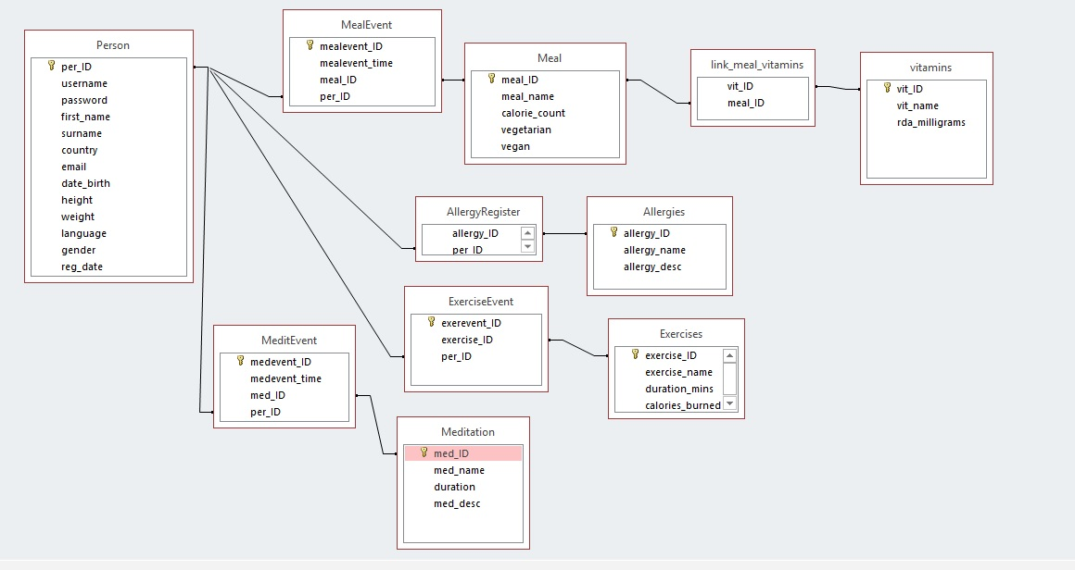

## Colours

Given the theme of the website I have decided to opt for the following colour palette for my website design.

 -> Main Green: Hex #368D45

 -> Blue: Hex #B84F46

 -> Golden Brown: Hex #B87D46

 -> Darkish Red: Hex #B84F46

Various lighter and darker shades of the above colours may be used during the development process if deemed to add to the website but mainly these four colours will be used for most areas.

I believe this combination of colours perfectly encapsulates the overall feel of Zenlike as being a calming place away from worries and stresses, a simple yet elegant interface for managing lives around busy schedules.

## Responsive Design

It is essential that the Zenlike website not only works on desktops but also on mobile and tablet devices also. To that end different types of screens sizes will have to be catered for and elements of my web application such as the calendar will need to be easily manipulated on a mobile screen. Media queries in CSS will be used as well as utilising percentage scales for most width parameters in the style sheet. Testing will take place on mobiles and tablets from both Apple OS and Android devices.